

**1203_04 - Modify Production Order in SAP -manual send data, change quantity or date or component, PO in Started status at GMES.**

**Process Definition Document (PDD)**

**Document History**

| Date | Version | Role | Name | Organization | Function | Comments |
| --- | --- | --- | --- | --- | --- | --- |
| 07.01.2020 | 1.0 | Author | K.NIROSH | ITC Infotech | Master Data | PDD V1.0 |
|  |  |  |  |  |  |  |
|  |  |  |  |  |  |  |

**Contents**

**1** **Process key contacts 4**

**2** **Minimum Pre-requisites for automation 4**

2.1 Pre-requisites for the Scenario**………………………………………………………………….4**

**3** **Test Cases (Scenario link from Teams) 4**

**4 Components not in Scope (External system Components)…………………………………………..**

**5** **Data To Be Used 4**

**6** **As Is Process Description 5**

6.1 As Is Process Overview 5

**7** **To Be Process Description 7**

7.1 To Be Detailed Process Map 7

7.2 Deviations / Technical decision taken for automation 9

**8** **In Scope for Automation 9**

**9** **Out of Scope for Automation 9**

**10** **Business Exceptions Handling 9**

10.1 Known Exceptions 9

10.2 Unknown Exceptions 9

10.3 Automation Exception…………………………………………………………………………10

**11** **Document Approval 10**

**12** **Screenshots of Manual Execution: 10**

# 13 Appendix………………………………………………………………………………………………………..26

# Process key contacts

| Role | Name | Contact details  (email, phone number) | Notes |
| --- | --- | --- | --- |
| Manual Flow Execution | K.NIROSH | k.niroshi@itcinfotech.com |  |
| Test Architect | Sonai Layek | [Sonai.Layek@itcinfotech.com](mailto:Sonai.Layek@itcinfotech.com) |  |
| Automation Tester | K.NIROSH | k.nirosh[@itcinfotech.com](mailto:Dharma.chaluvadi@itcinfotech.com) |  |

# Minimum Pre-requisites for automation

# 

| S. No | Application name & version | Type | Test Data Required |
| --- | --- | --- | --- |
| 1 | Delmia Apriso 2019 Desktop Client | Desktop | Loipro (Download Production Order) |
| 2 | SOAP API | API | Loipro |

2.1 **Pre-requisites for the Scenario**

Please refer the attached document.



# Test Cases (Scenario link from Teams)



# Components not in Scope (External System Components)

* ECC_CO02_IFT_Change parameters of Production Order in TaO.

# Data To be used

| S. No | Application name | Test Data Required |
| --- | --- | --- |
| 1 | Delmia Apriso 2019 Desktop Client | | 1. LOIPRO/ProductionOrderData – 2 smd loipros | | --- | |  | |
| 2 | SOAP API | 1. LOIPRO/ProductionOrderData – 2 smd loipros idocs. |

# 

# As Is Process Description

This portion highlights the actual design of the business process before automation

## As Is Process Overview



**Input** : LOIPRO/ProductionOrderData xml from Mock Server.

**Output**: LOIPRO/ProductionOrderData success in GMES.

**Standard Test Data to be used** (if any) : NA

# To Be Process Description

This portion highlights the expected design of the business process after automation.

* The symbol in the below flow chart displays the process exceptions where the workaround needs to be performed based on the below mentioned Exception section 9.1. 
* The process in the below flow chart highlighted in red explains the deviation from the maual process to perform the automation in obtaining the final end result is explained in section 6.2 of the document. 

## To Be Detailed Process Map



**Input** : LOIPRO/ProductionOrderData xml.

**Output**: LOIPRO/ProductionOrderData success status.

**Standard Test Data to be used** (if any) : NA

**Key Validations / Assertions**

1. Successful processing of LOIPRO xml by SOAP API.
2. Validate if the LOIPRO is processed successfully in Immediate Jobs History.
3. Validate all the details of the LOIPRO in Execution Orders.
4. Open the work center in which you process the LOIPRO
5. Prepare the PO, which you sent and Start PO.
6. Reprocessed the Started PO on changing the Quantity, Start Date, End Date.
7. Validate if the LOIPRO is processed successfully in Immediate Jobs History.
8. Validate all the details of LOIPRO in Execution Order.
9. Open the work center and validate if Updated Values are appearing in work center.

## Deviations / Technical decision taken for automation

1. **Why do we use mock server instead of SAP OER for all SAP Test cases ?**

We don’t have SAP OER integration during GMES testing; thus we are triggering the Idocs through XMLs from Mock server**.** We send the messages through SOAP UI.

The mock server is replica of SAP application and there we can view if the outbound xmls are received in correct format or not. Also, its integration in the testing framework ensures its fast and efficient

**Note**: Moving forward: Deviation/Judgement call if known in advance will be covered in PDD else it would be captured in a supporting document and provided at the time of review and approval sign off.

# In Scope for Automation

Using LOIPRO/Production Order Data xml to create new PO in the work center.

# Out of Scope for Automation

SAP Application.

# Business Exceptions Handling

## Known Exceptions

During triggering xmls from SOAP API message processing can fail due to connectivity issue or firewall issue.

## Unknown Exceptions

## NA

## Automation Exceptions

We are triggering the XMLs from SOAP UI instead of SAP.

# Document Approval

This document requires serial approval (sign off) from the roles defined in the table below.

Changes to the requirements must be documented in an updated version (i.e v 2.0) and requires a new signature flow.

| Version | Flow | Role | Name | Organization  (Dept.) | Approval Date: |
| --- | --- | --- | --- | --- | --- |
| **1.0** | **Document prepared by** | **Automation Tester** | K.NIROSH | ITC |  |
| **1.0** | **1st Level Approver** | **1)Tech Architect**  **2) Project Manager** | Sonai Layek  Pavan Kumar Potnuru | ITC |  |
| **1.0** | **Final Review** | **Test Manager** |  | BAT |  |
| **1.0** | **Sign Off** | **Test Manager** |  | BAT |  |

# 13 Screenshots of Manual Execution:

This section presents the screenshots of validation steps for Scenario:

**1203_02 - Modify Production Order in SAP manual send data, change quantity or date or component, PO in Started status at GMES**

**Component 1. ECC_YSMR_ITF_ Send IDOC manually to MES**

Step 1.1: Trigger the xml from SAP to GMES (keep xml in the Flex net File Processor archive queue)

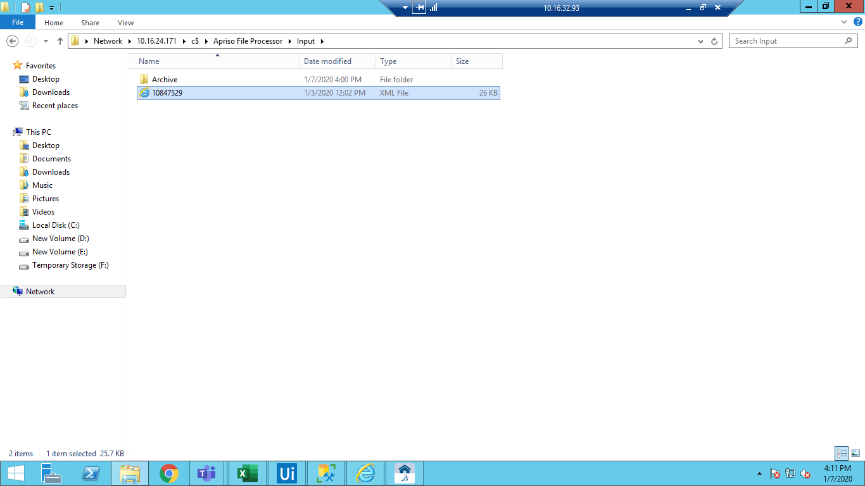

Xml processed successfully.

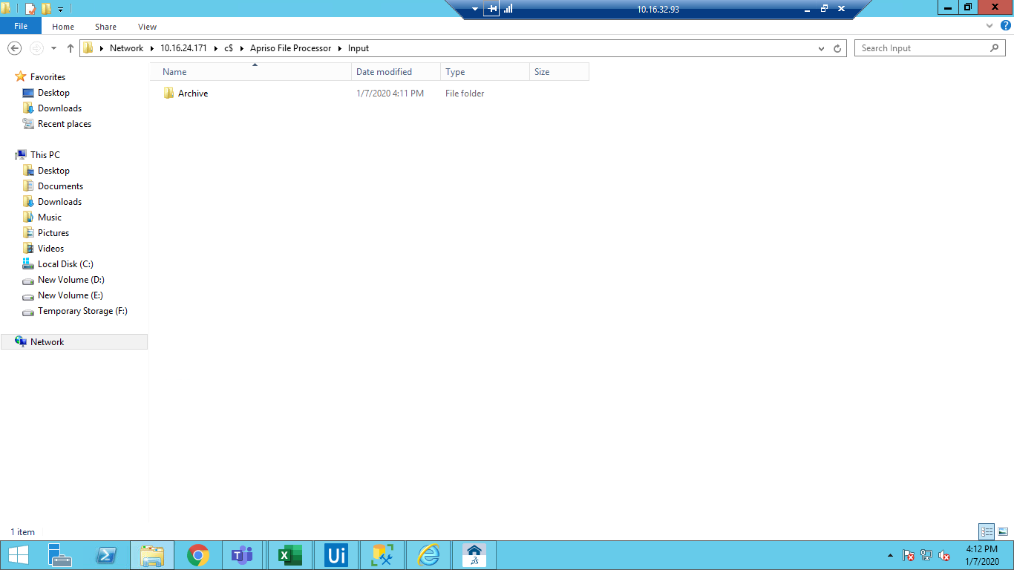

**Component 2. ADM_JobHistory_MM_Check LOIPRO message**

Step 2.1: Navigate to immediate jobs history (JE_IJH) from Desktop client.

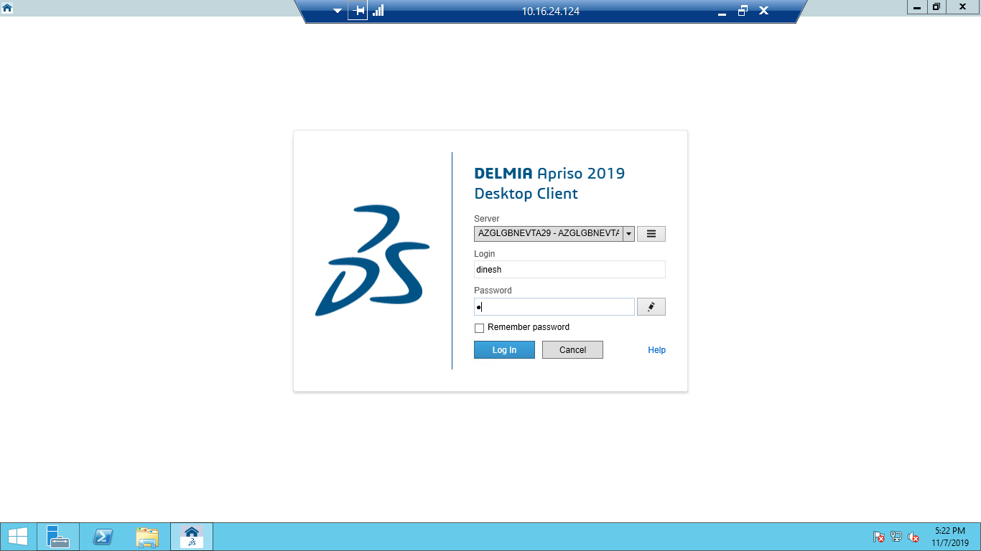

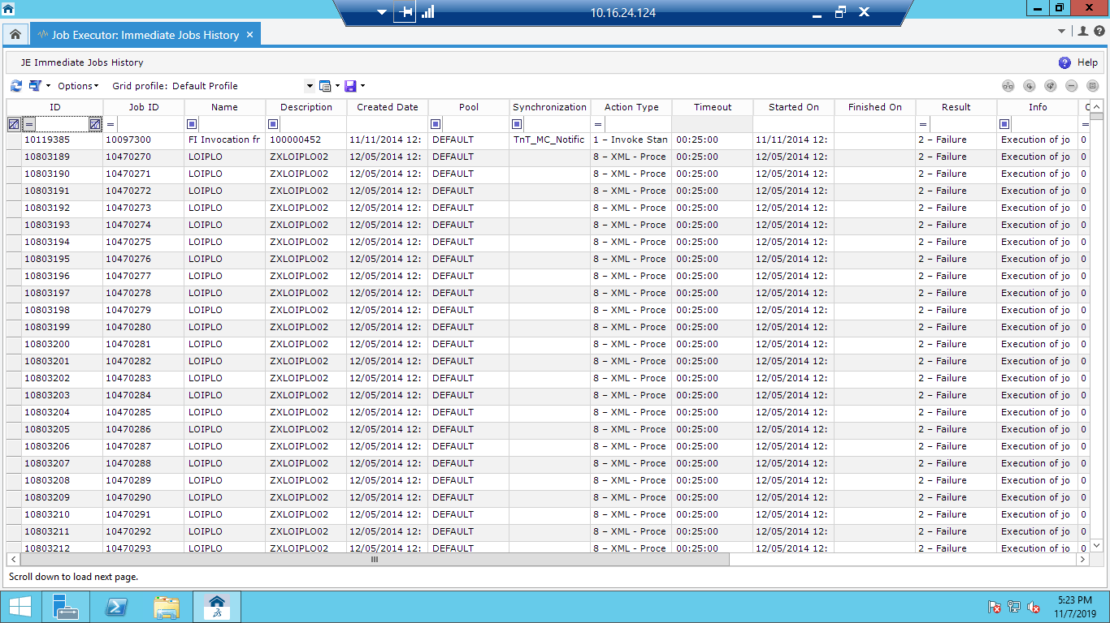

Step 2.2 For new downloaded LOIPRO(PO) from SAP and PO is in new status:

Put LOIPRO in description column and search for the latest message

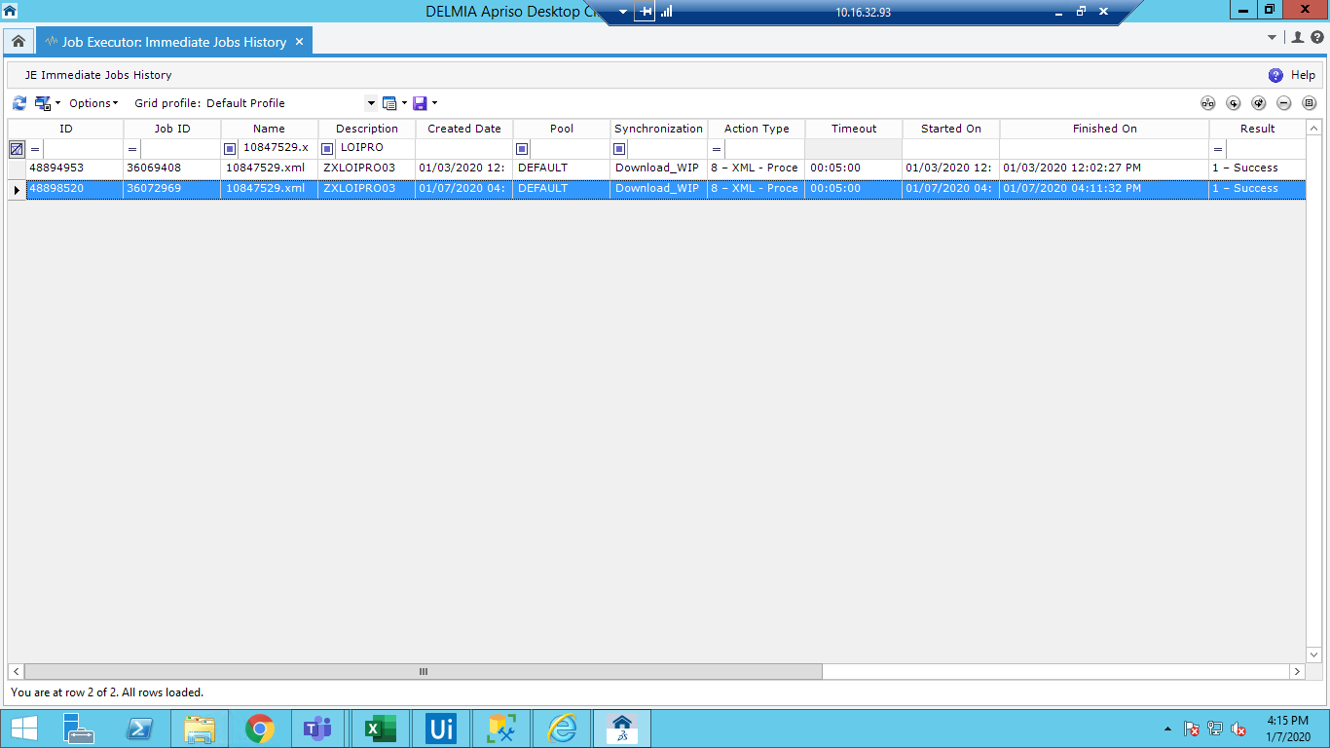

Step 2.3: Open the message and validate it



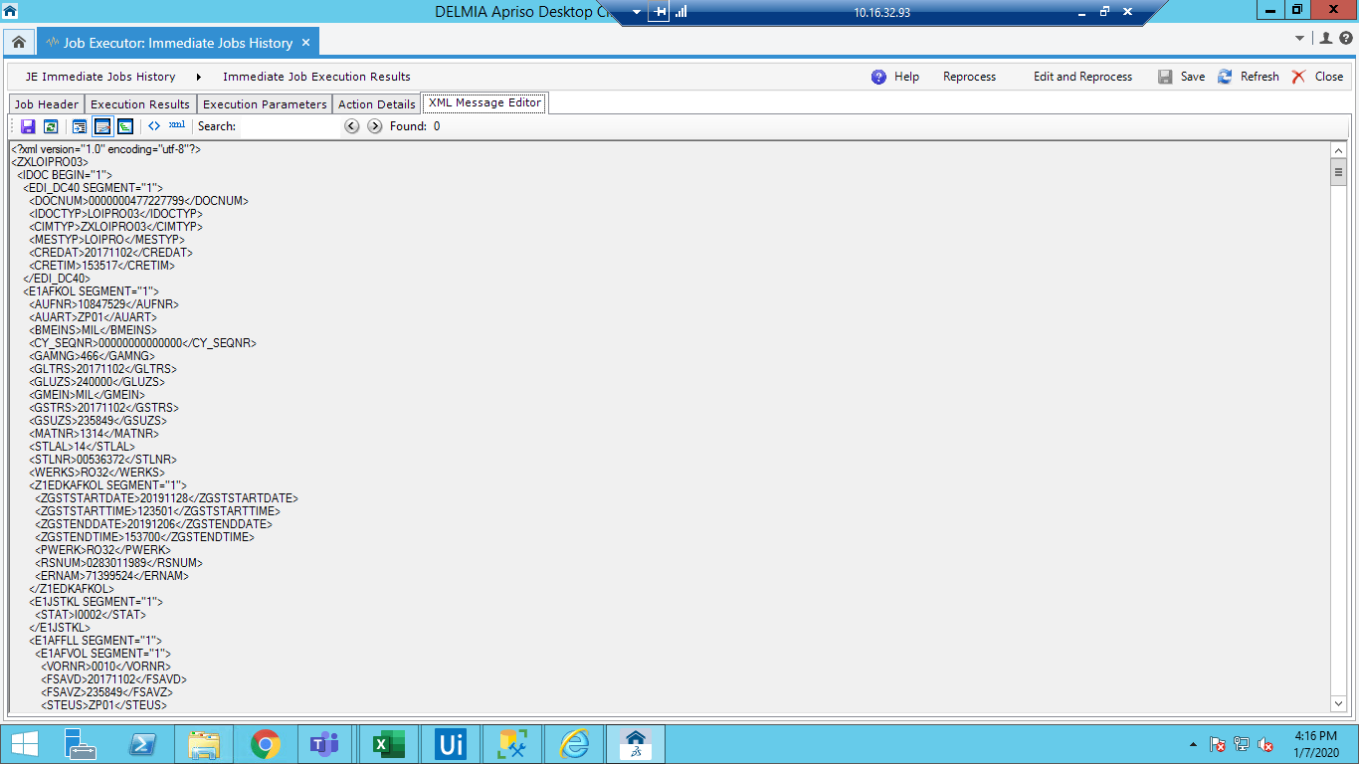

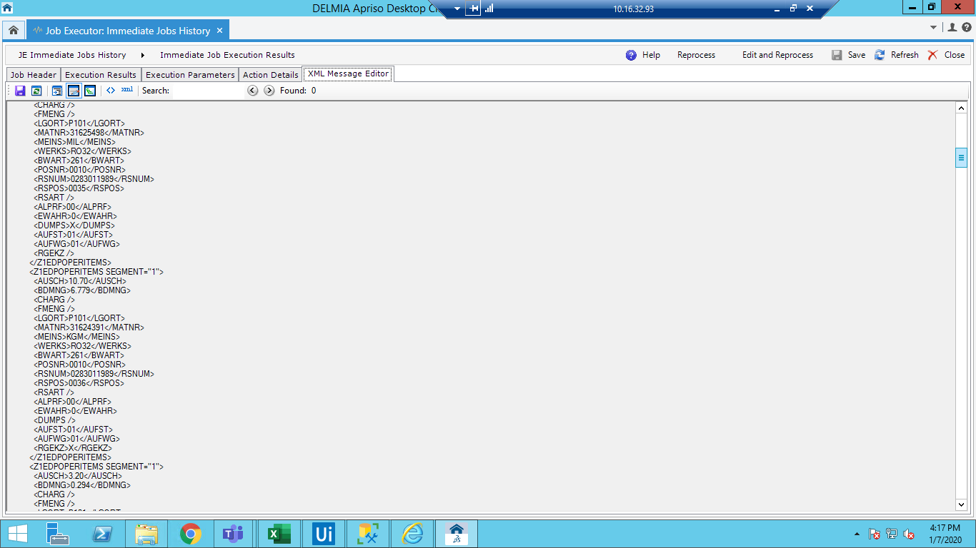

Start the PO in work Center

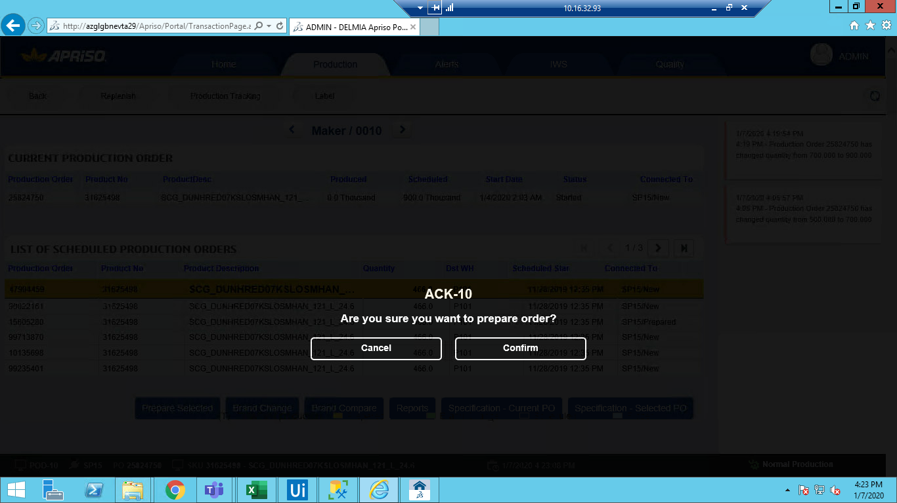

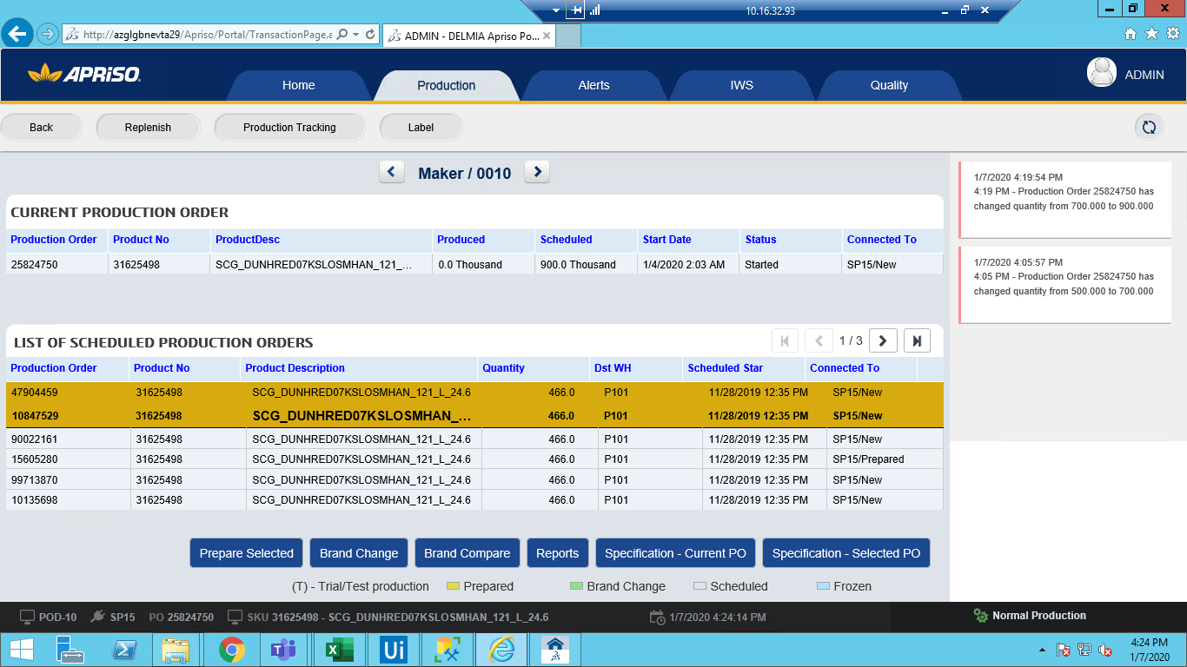

Started The Po

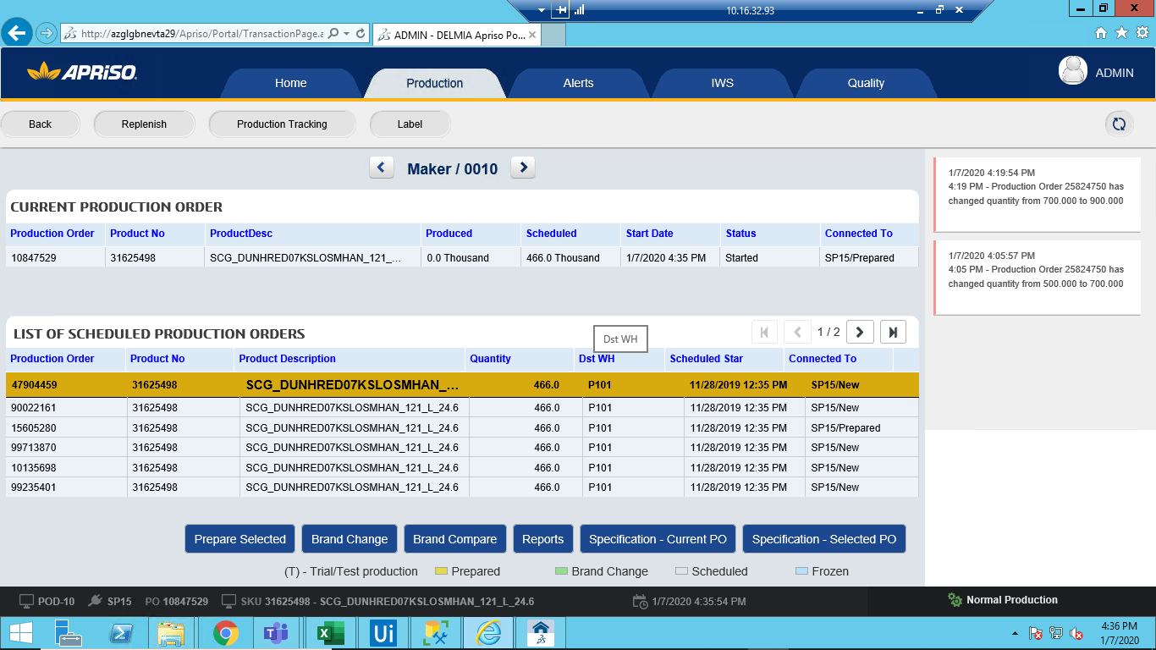

Step 2.4: For reprocessed LOIPRO(PO) from SAP and PO is in Started status:

Put LOIPRO in description column and search for the latest message.

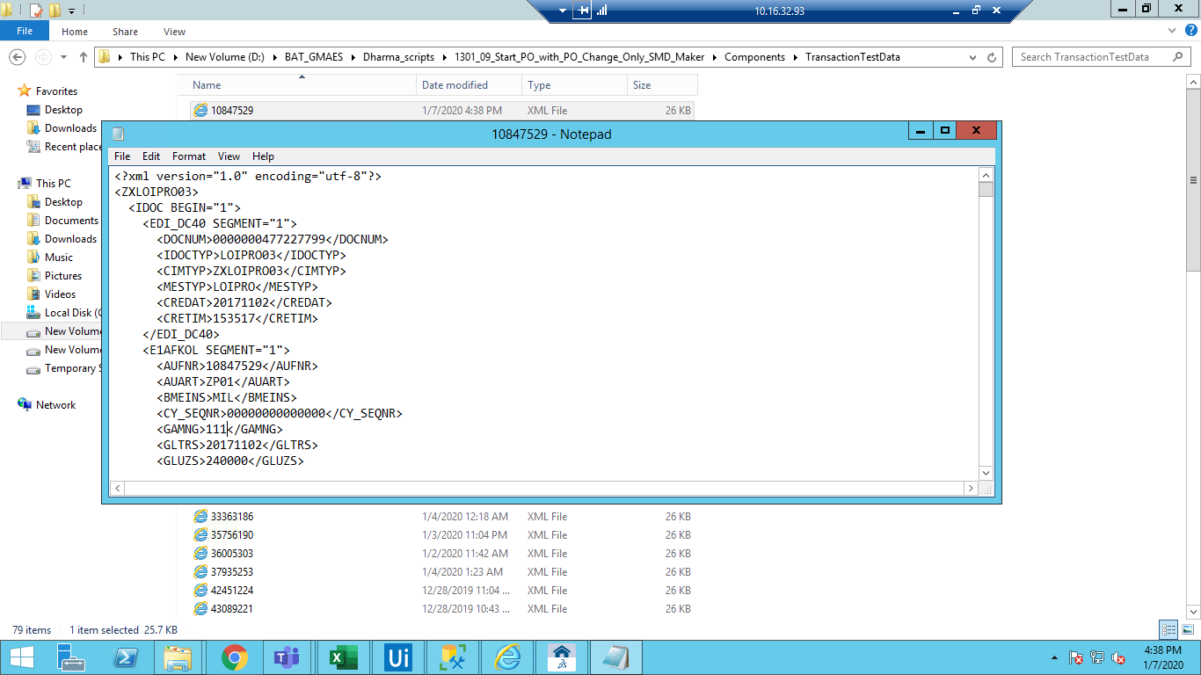

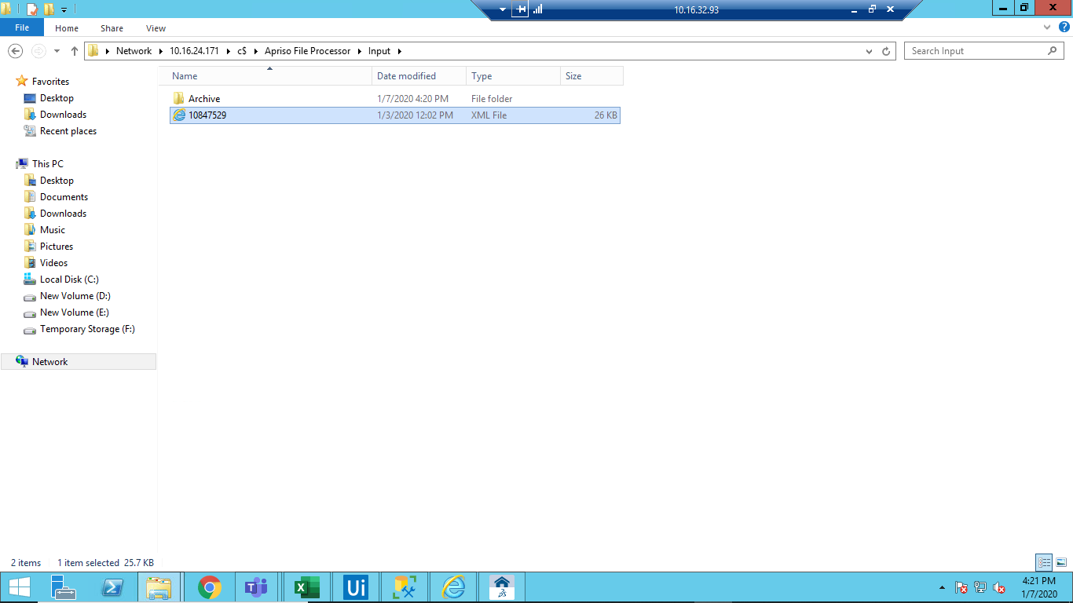

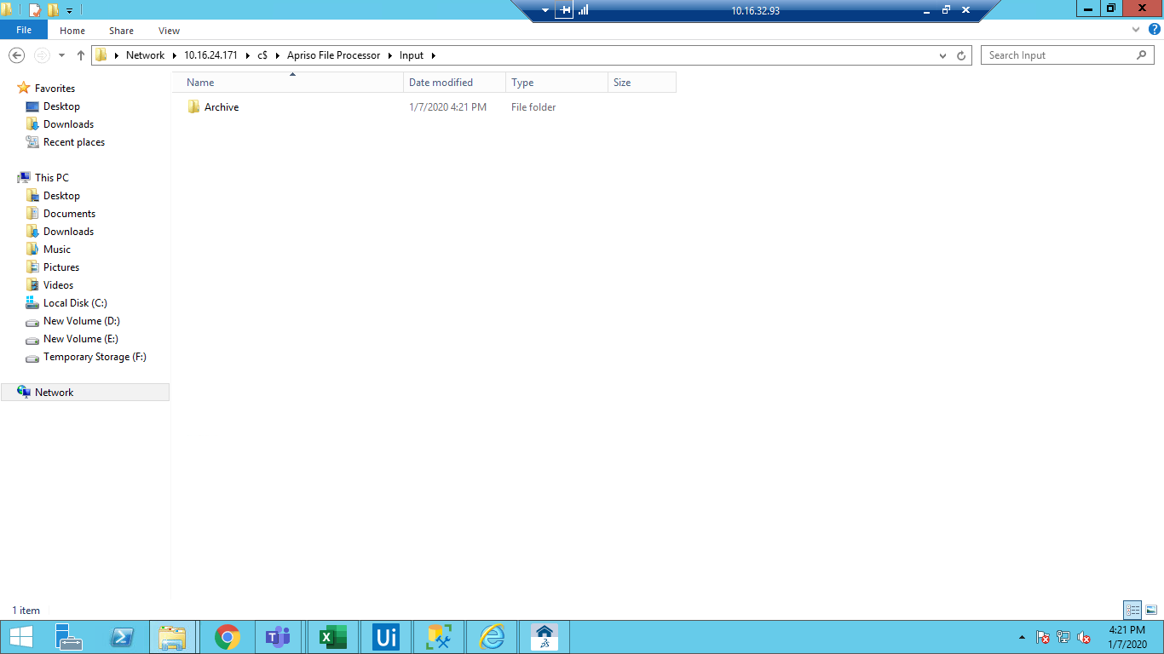

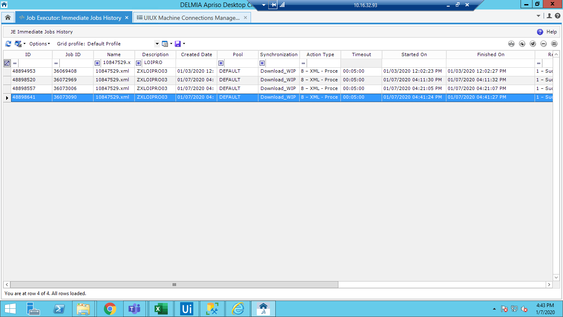

Step 2.5: Open the message and validate it.

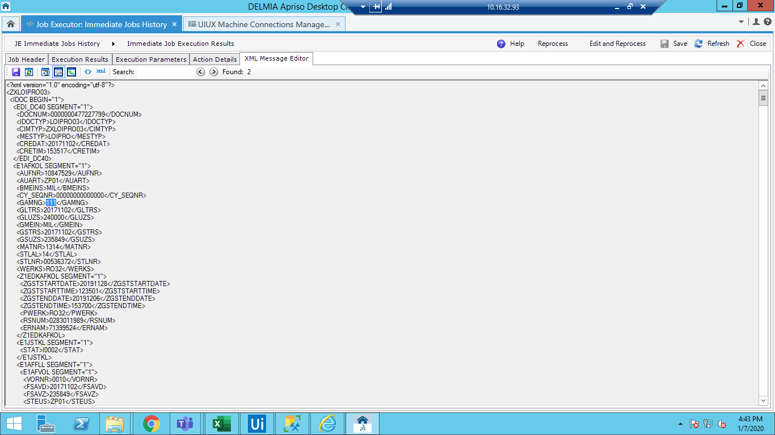

**Component 3. MFG_ExecutionOrder_MM_View Production Orders (split) / MFG_ExecutionOrder_MM_View Production Orders (no split)**

Step 3.1: Navigate to Execution order screen Monitoring Tools e>> Order Cockpit>> Execution

Order(OC_EXO)

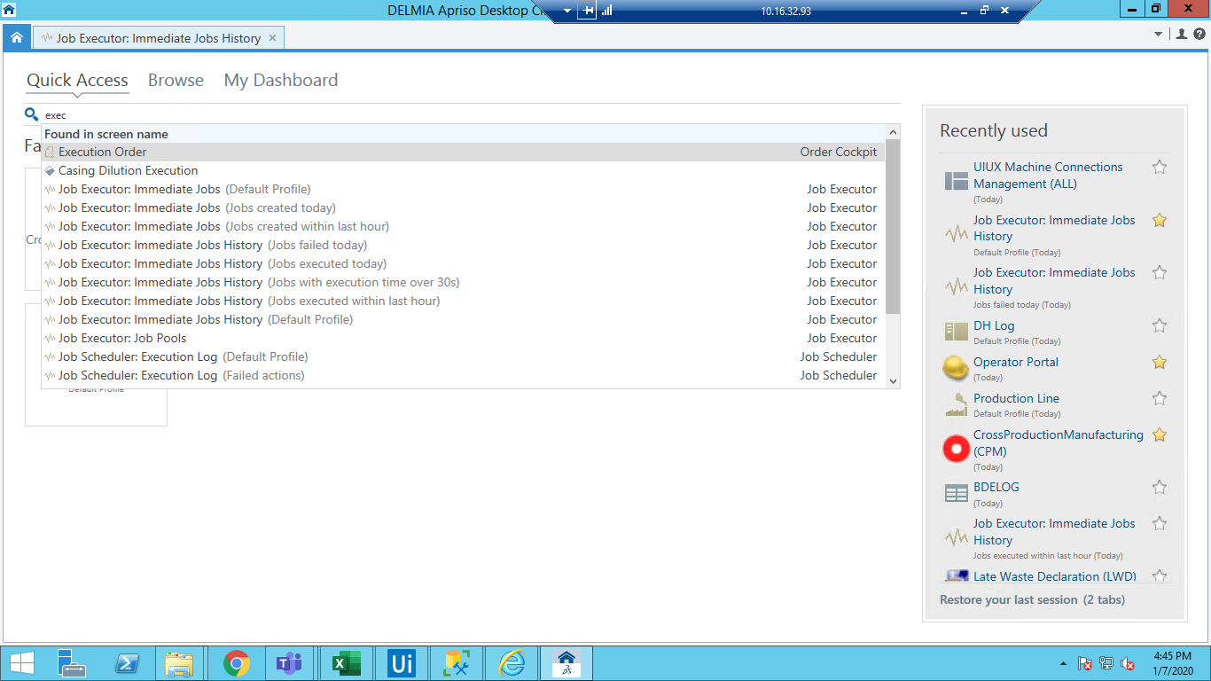

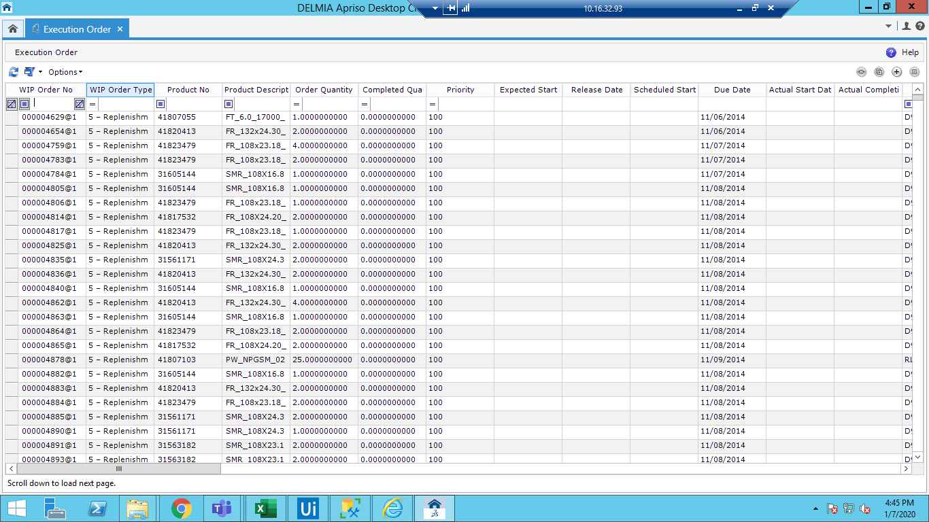

Step 3.2: Launch Scanner Simulator and click on Change View

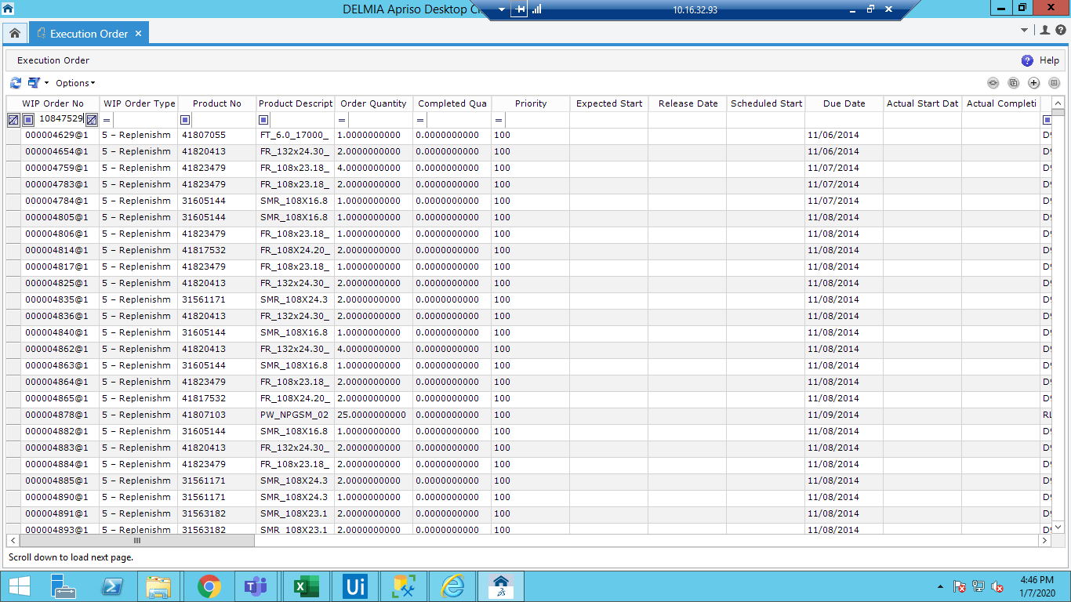

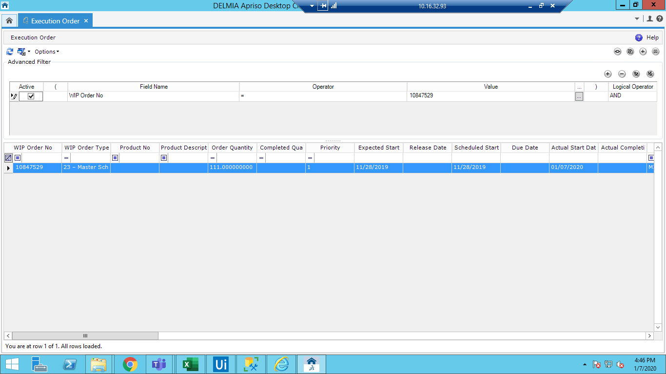

Step 3.3: Select the PO and click on "Edit Execution order" button

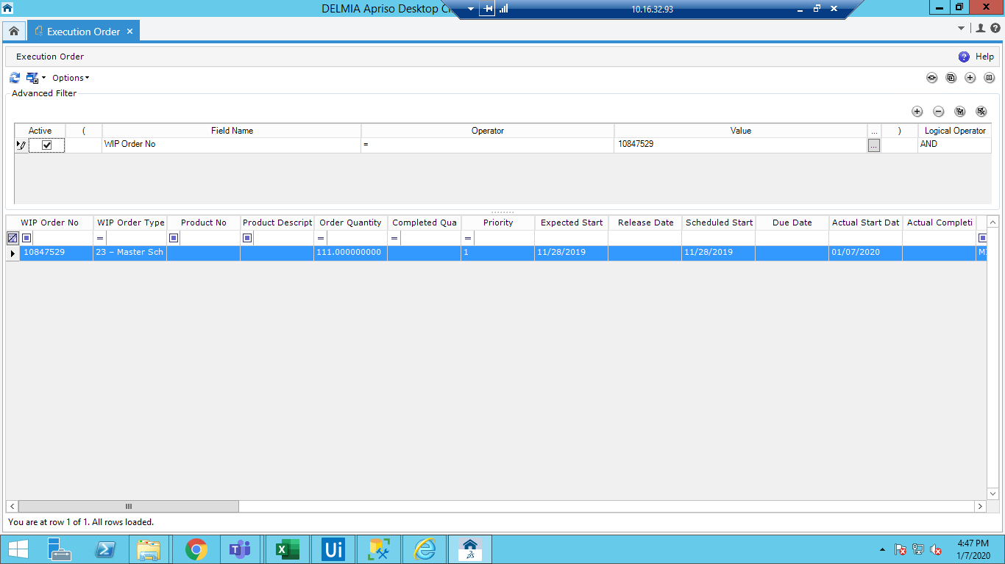

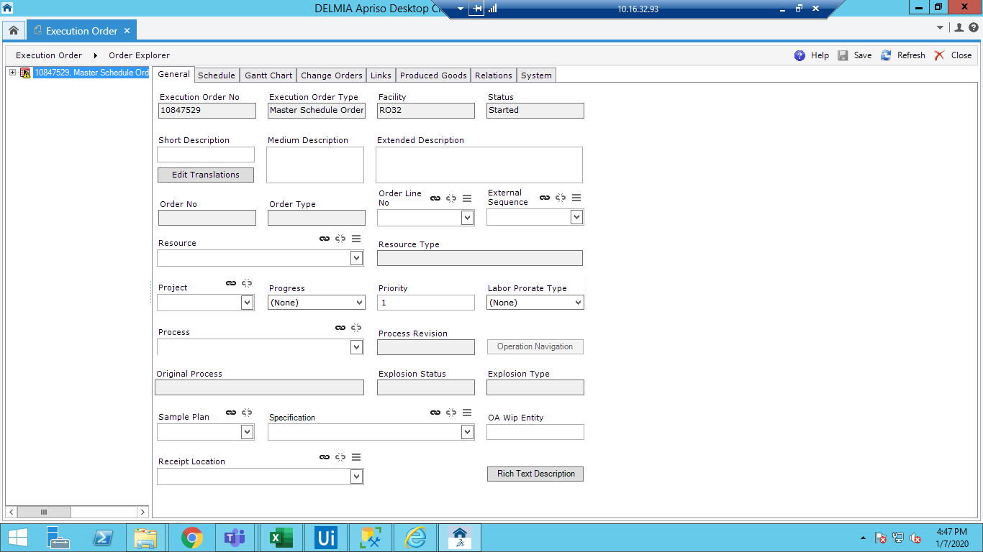

Step 3.4: Observe The "General" tab.

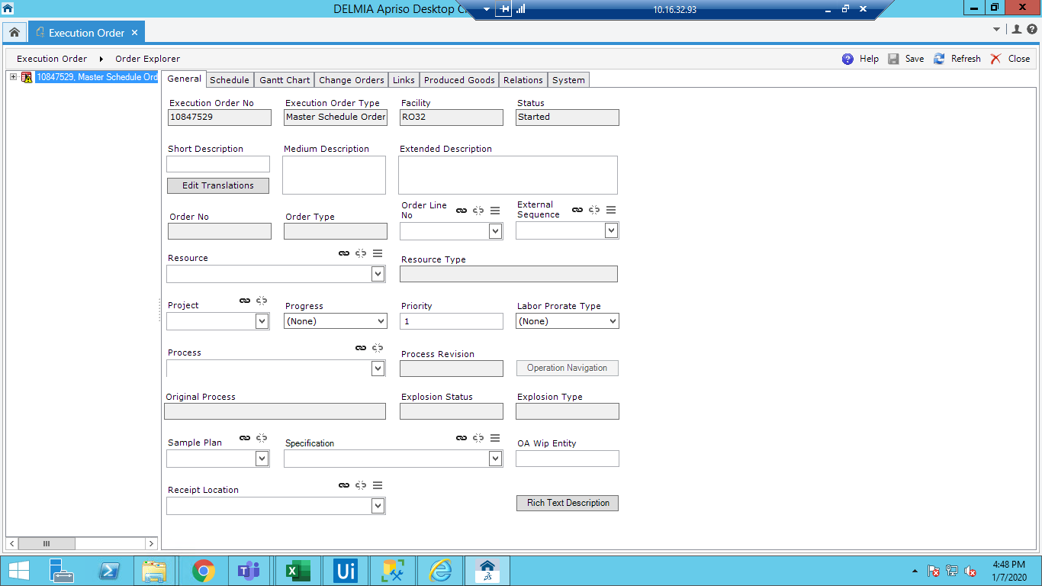

Step 3.5: Click on "Schedule" tab.

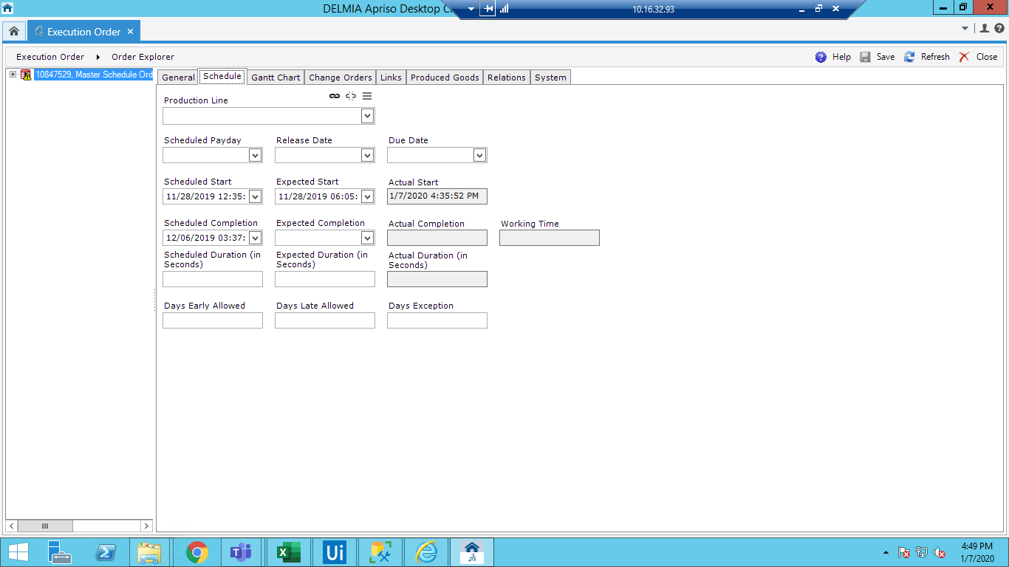

Step 3.6: Click on Links tab and click on "Components" link

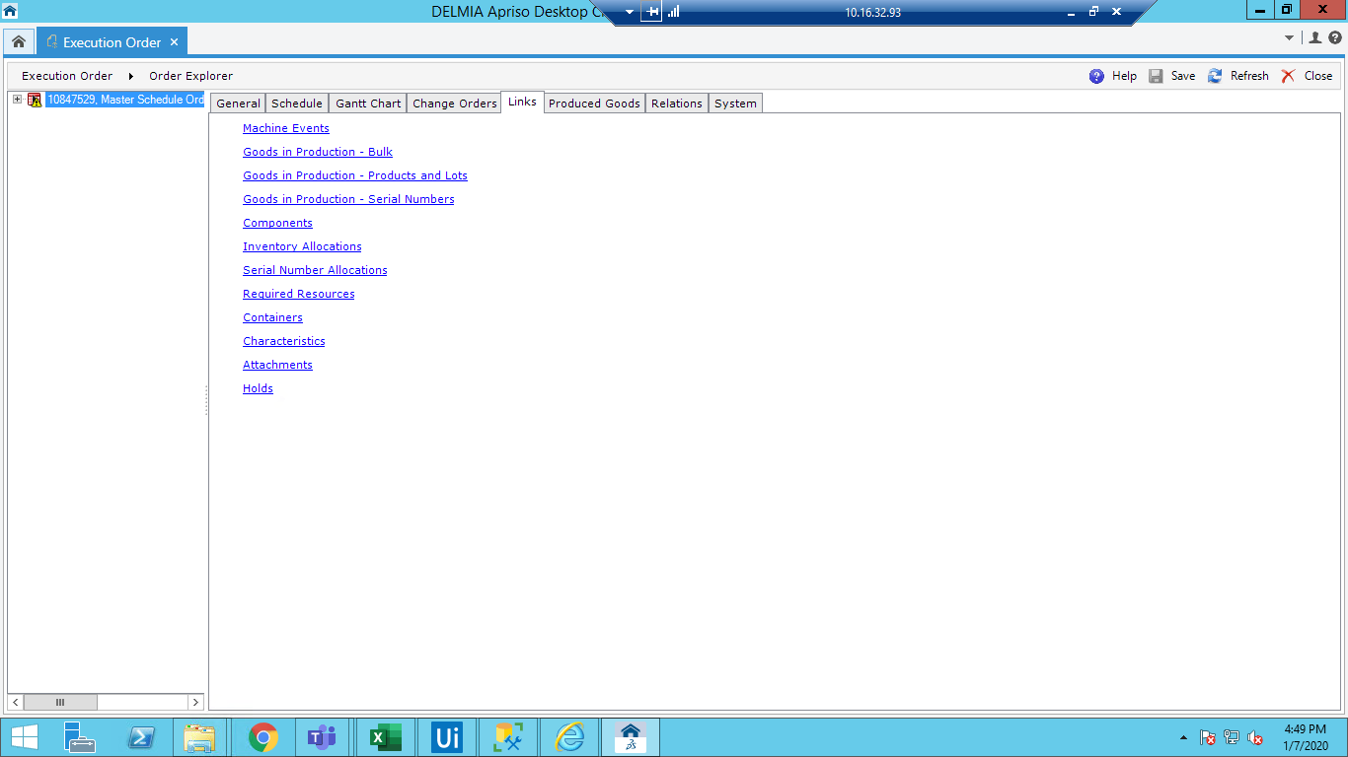

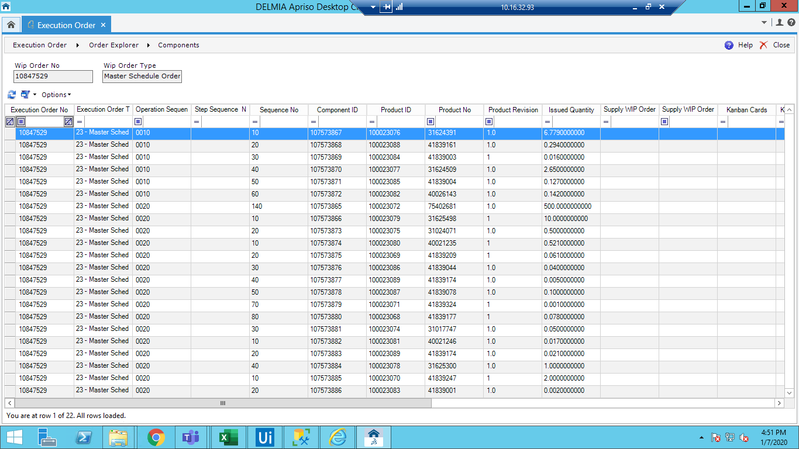

Step 3.7: Click on Links tab and click on "Required Resource" link

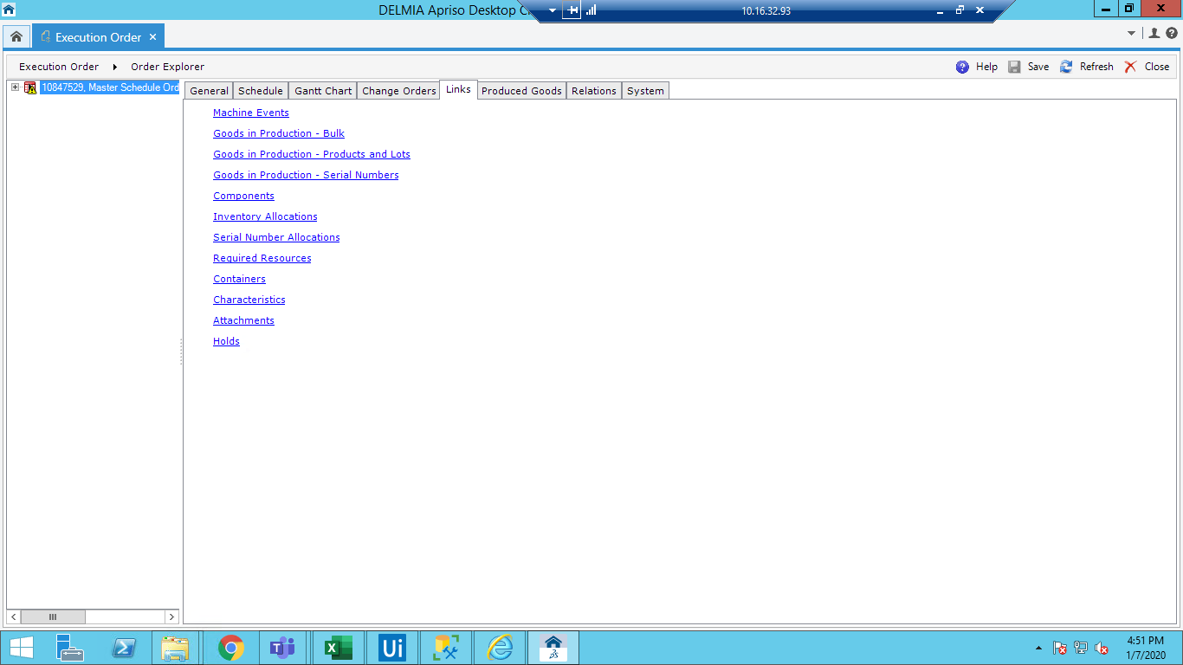

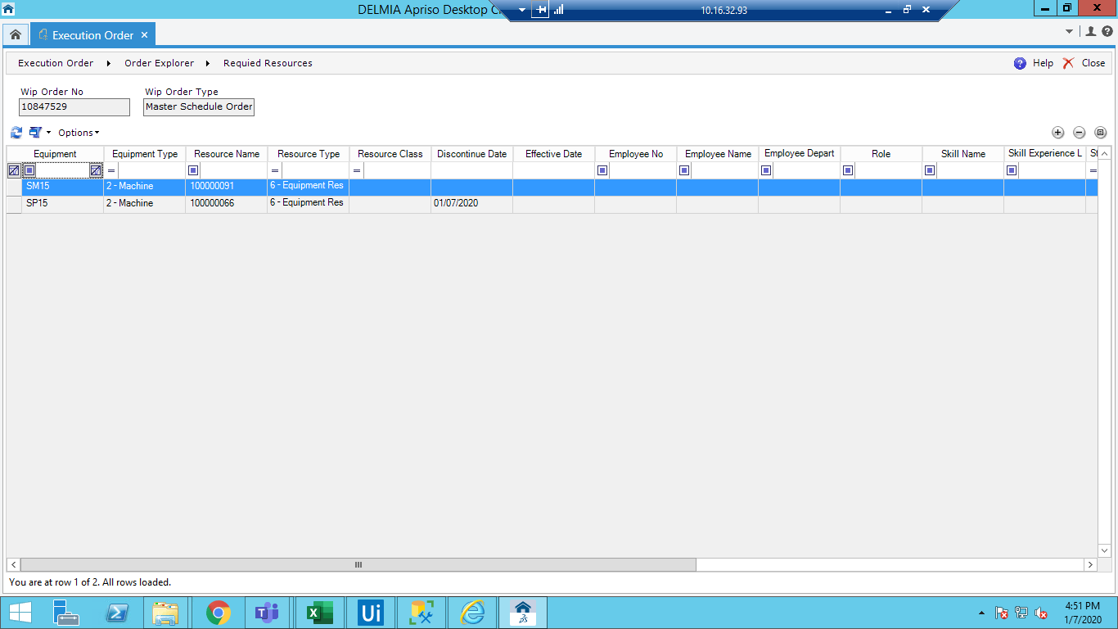

Step 3.8: Click on "Produced Goods" tab.

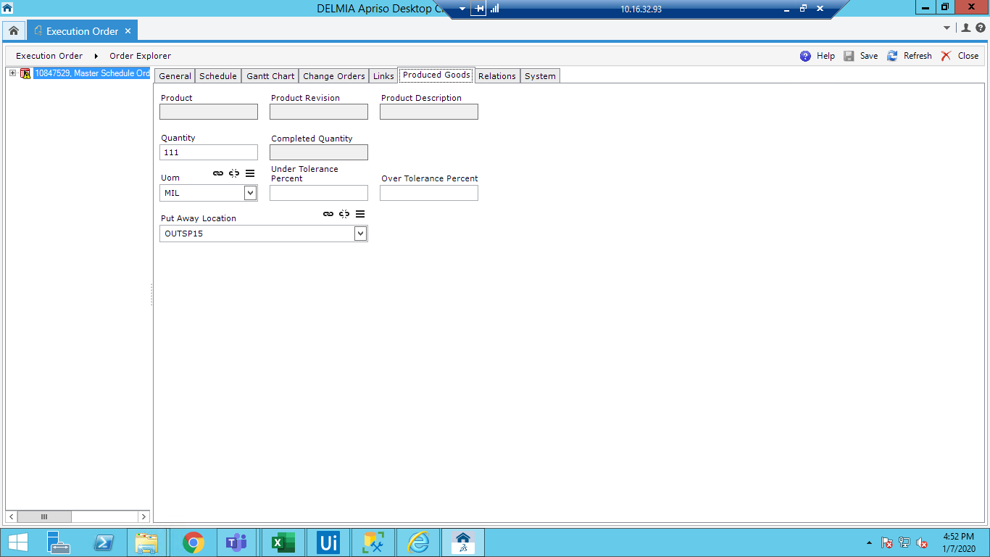

# Appendix

**NA**